Risk Management
Name
Institution

Risk Management
Introduction
Risk assessment is an important component of investments. An investor should manage the risk in their portfolio to get optimal returns and avoid losing all or part of their investment. Risk management can be based on fundamental, technical, and/or sentimental analysis. This paper evaluates some of the options that can be used for risk management.
Methodology
We checked four stock which were used to analyze the effect and impact that different risk management strategies may have on the overall portfolio risk and the return on investment (Marty, 2013). The five stock are Starbucks Corporation (SBUX), Dunkin’ Brands Group, Inc. (DNKN), The Cheesecake Factory Incorporated (CAKE), and Texas Roadhouse, Inc. (TXRH). Price data for the companies was collected from year 2014 to 2018 (5 Years).
Data Description
Figure 1: SBUX
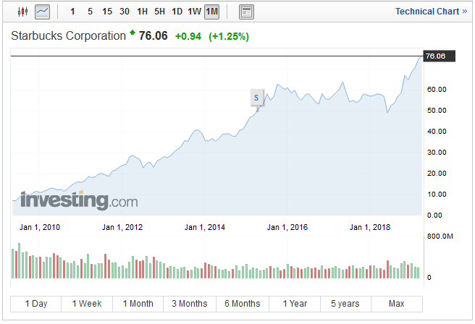
Source: (Starbucks Corporation, 2019)
Figure 2: DNKN
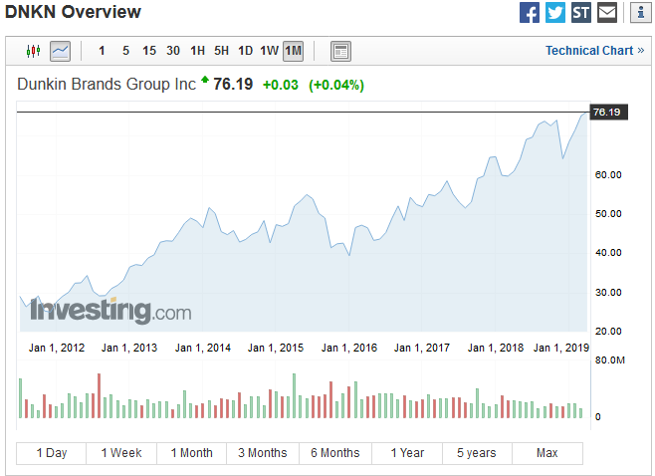
Source: (Dunkin Brands Group Inc, 2019)
Figure 3: CAKE
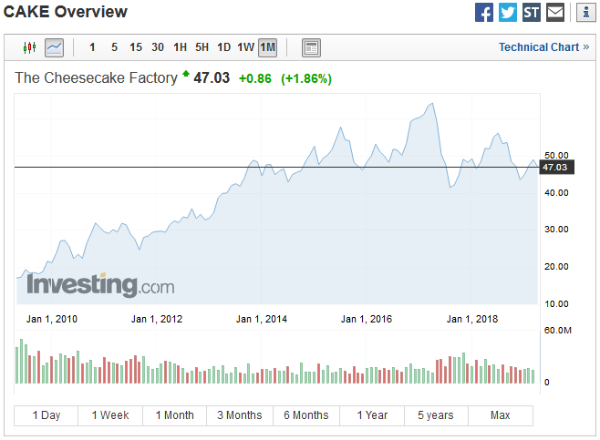
Source: (The Cheesecake Factory, 2019)
Figure 4: TXRH
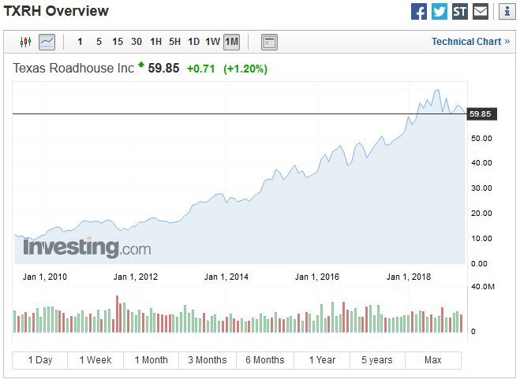
Source: (TXRH Overview, 2019)
Table 1: Fundamental Analysis
 | SBUX | DNKN | CAKE | TXRH
Revenue | 25.28 B | 1.32 B | 2.33 B | 2.46 B
EPS | 2.27 | 2.71 | 2.14 | 2.2
Dividend (Yield) | 1.44 (1.92%) | 1.50 (1.97%) | 1.32 (2.86%) | 1.2 (2.03%)
P/E Ratio | 33.49 | 28.11 | 22.02 | 27.21
Beta | 0.49 | 0.48 | 0.33 | 0.66
Market Cap | 94.59 B | 6.29 B | 2.13 B | 4.29 B
Average Vol. (3m) | 10,256,930 | 754,980 | 744,061 | 810,401
Industry
Source: (Dunkin Brands Group Inc, 2019; Starbucks Corporation, 2019; TXRH Overview, 2019; The Cheesecake Factory, 2019)
Beta
Beta compares the volatility of a stock to the market index volatility. A beta that is equal to one means that a stock has the same level of volatility as the market index. A beta that is below one means that a stock price has a low volatility compared to the market index volatility. A beta that is higher than one means that the stock’s volatility is higher than the market index volatility (Kensinger, 2018). The four stocks all have a beta that is less than one. This means that their prices do not fluctuate widely, therefore reducing the risk posed by each to the market.
Value at Risk
Value at risk (VaR) is the proportion of a fund exposed to any one stock. For instance in our case, by dividing the investment funds into four, the value at risk exposed by investing in each of the stocks is 25 percent of the overall fund. By limiting the exposure to any particular stock, it is possible to mitigate against any adverse events that may affect the performance of the stock. Close to the value at risk concept is diversification (Choudhry, 2013). Diversification helps in minimizing exposure to any particular industry or stock.
Stop Loss Limit
The stop loss limits help reduce the amount of loss incurred when a stock experiences a rapid downturn. Stop losses are sale instructions that are triggered when the price of a stock goes below a certain point. When setting the stop loss limit, an investor should consider the short term volatility of a stock (Loton, 2009). The stop loss limit should be set in such a way that it is not triggered by short term price volatility, such as the hourly or daily fluctuations, but by large stock price movements.
Results
The risk management approaches mentioned above helped in obtaining consistent return. By following the trend between the years 2014 to 2018, an investor would have made a reasonable return on all the four stocks as has been shown in the price charts above.

References
Choudhry, M. (2013). An Introduction to Value-at-Risk. West Sussex: John Wiley & Sons Limited.
Dunkin Brands Group Inc. (2019). Retrieved from investing.com: https://www.investing.com/equities/dunkin-brands-group
Kensinger, J. W. (2018). Growing Presence of Real Options in Global Financial Markets. Bingley: Emerald Publishing Limited.
Loton, T. (2009). Stop Orders: A practical guide to using stop orders for traders and investors. Hampshire: Harriman House Limited.
Marty, W. (2013). Portfolio Analytics: An Introduction to Return and Risk Measurement. New York: Springer.
Starbucks Corporation. (2019). Retrieved from Investing.com: https://www.investing.com/equities/starbucks-corp
The Cheesecake Factory. (2019). Retrieved from investing.com: https://www.investing.com/equities/the-cheesecake-factory
TXRH Overview. (2019). Retrieved from investing.com: https://www.investing.com/equities/texas-roadhouse

